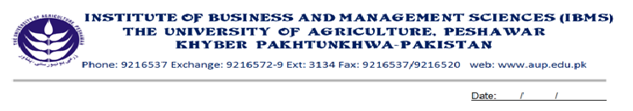
Programme: BS (CS)-VII
Course Title: Distributed Database Systems
Course Code: CS-604
Session: 2009-2012
Course Hours: 03
Total Weeks: 16
Total Credit Hours: 48

Course Objectives:
This course introduces the fundamental concepts and issues of distributed database systems. And the approaches of emerging technologies, and to provide insight into related research problems. In this course students will analyze relational database applications with special concentrations on the design of relation, queries, procedures and connections. Describe and use techniques to improve performance object-oriented database systems. It also elaborates the shortcomings of centralized relational database systems, and how to overcome these shortcomings using DDBMS.

Week-1
- What is Distributed Database System?
- Distributed Data Processing
- Advantages of data DDBS

Week-2
- Relational Database Concepts
- Normalization
- Integrity Rules

Week-3
- Data communication Concepts
- Types of Networks
- Protocols Standards

Week-4
- Client/Server Systems
- Peer-to-peer Distributed Systems
- MDBS Architecture

Week-5
-Characterization of Query Processors

Week-6
- Layers of Query processing

Week-7, 8
- Fragmentation
- Reasons for Fragmentation
- Types of Fragmentation

Week-9, 10
- Parallel DBMSs
- Database Servers
- Centralized Database Systems

Week-11, 12
- Properties of Transactions
- Concurrency control Techniques
  - Locking Methods
  - Dead Lock
  - Timestamp Method

Week-13
- Recovery
- Causes of Failure
- Local Recovery Protocols
  - Undo/Redo
  - Undo/No-Redo
- Distributed Recovery Protocols
-Distributed Two Phase Commit

Week-14
- Integrity Constraints
- Securities Issues in Distributed Databases
  - Identification & Authorization
  - Distribution of Authorization
  - Encryption
  - Global view Mechanism
Week-15
- Data ware Housing introduction
- World Wide Web introduction

Week-16
- Revision

Total Marks: 100
Recommended Book:
1. Principles of Distributed Systems By M. Tamer Ozsu

